_________ ____________
Student ID Student Name

Lab 10: Functions in C++

Objective:
The objective of this lab is to understand the concept of functions in C++, explore formal and actual parameters, and comprehend the differences between call by value and call by reference.
Equipment Needed:
- Computer with a C++ compiler (e.g., g++, Visual Studio)
- Text editor or Integrated Development Environment (IDE)

Introduction:

Theory:

A function is a set of statements that takes input, does some specific computation, and produces output. The idea is to put some commonly or repeatedly done tasks together to make a function so that instead of writing the same code again and again for different inputs, we can call this function.
In simple terms, a function is a block of code that runs only when it is called.
Syntax:-

return_type function_name (parameters) {
// Function body
}

Example:-01 function without parameters

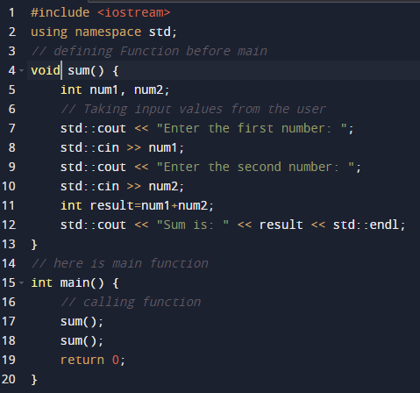

Example:-02 call by reference

#include <iostream>
// function that takes two parameters using pointers
void swapvalueswithpointers(int* num1, int* num2) {
int temp = *num1;
*num1 = *num2;
*num2 = temp;
}
int main() {
int num1 = 5;
int num2 = 10;
std::cout << "before swap: num1 = " << num1 << ", num2 = " << num2 << std::endl;
// call the function with pointers to the variables
swapvalueswithpointers(&num1, &num2);
std::cout << "after swap: num1 = " << num1 << ", num2 = " << num2 << std::endl;
return 0;
}

Example:-03 solve this concept

Convert this program according to c++ language.
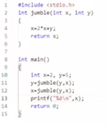

Student Tasks:

- Run all the above examples and attached the output.

- Run the below code attach the output and write working of it in your own words.

